# Install node.js (one time setup)

# Start node.js server

# In tableau data>new data source > web data connector

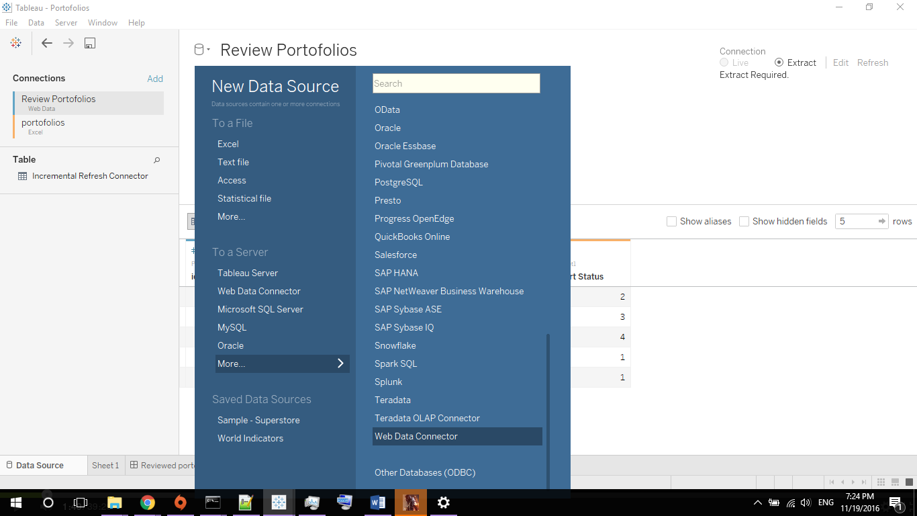

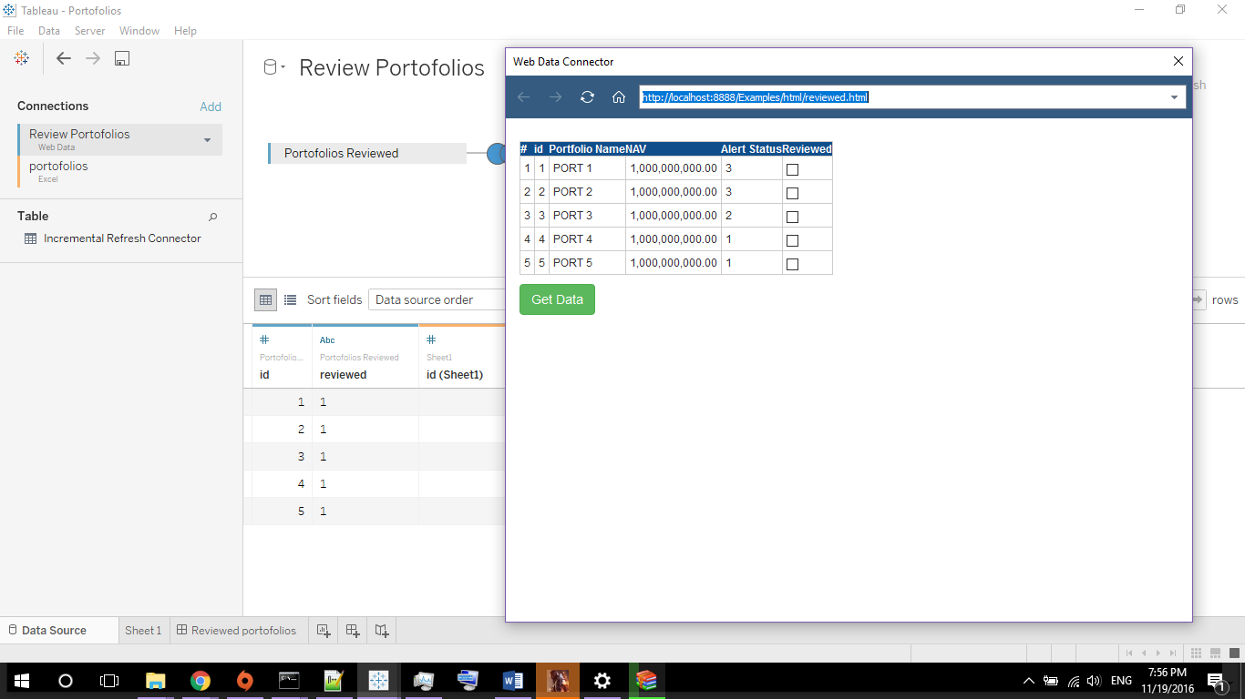

Type the html page node.js url in the address bar

<http://localhost:8888/Examples/html/reviewed.html>

# To change values of the reviewed field press edit connection on the data source

